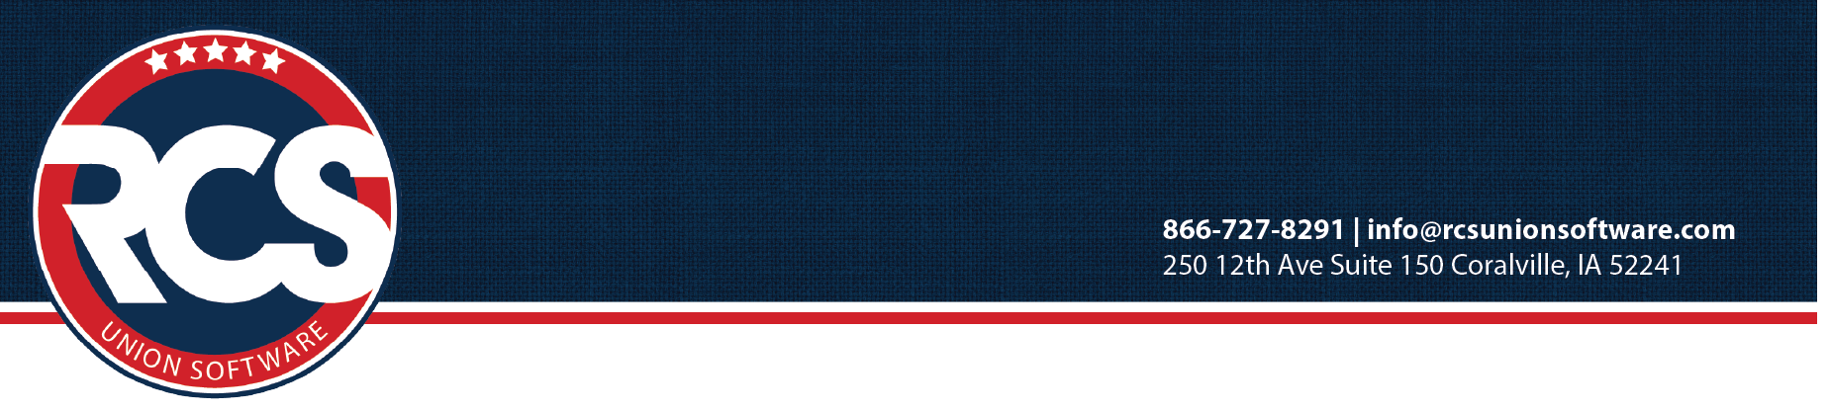

February 2025

Greetings 2025 Conference Attendees,

We look forward to seeing you at the March UAW Financial Officers’ Conference in Atlanta!
Our main goal of the conference is to assist you in successfully and accurately completing your LM and 990.
To meet this goal, we ask you to bring the following information as it relates to your local.

To complete your LM-2 form for 2024 at FOC (BRING THE FOLLOWING) . . .

- 2024 LM Prep Worksheet You must complete this preparation prior to coming to Conference.

If you run in to any issues, please resolve with RCS Support before coming to Conference.

- Calculator
- Copy of the 2023 LM filed with the DOL

Print the following LM reports:

- LM-2 Worksheet Reports Menu> LM Tab> Select 2024 then generate and print a Worksheet
- LM-2 Schedules Reports Menu> LM Tab> Select 2024 then generate and print each of the schedules

For LM Statements A and B, bring the following items:
- January 2025 Financial Report Reports Menu> Financial Tab. Run the Financial Report for the date range of January 1 - 31 2025. (This is used to determine liabilities as of 12-31-2024.)
- Investment statements as of December 31, 2024
- Detailed Asset Listing as of December 31, 2024 for LM statement B
- Detailed List of Assets Purchased and Sold in 2024 & related costs to sell for LM statement B
- Detailed Inventory Listing as of December 31, 2024
- Detailed list of Inventory Sold in 2024 & related costs to sell
- Bank Mortgage Detail January 1 – December 31, 2024 as applicable or any notes payable as of 12/31/24

Expense & Income reports needed: (run reports for all funds.)
- A-43 Cash & Fund Summary Reports Menu> Financial Tab. Run the A-43 for December of 2024.
- A-42/A-132 Report Monthly Summary of Cash Received Reports Menu> Income & Expenses Tab.
Run the A-132 for the full year of 01/01/2024 – 12/31/2024
- 2024 Financial Report Reports Menu> Financial Tab
Run the Financial Report for the full year of 01/01/2024 – 12/31/2024

To complete 990 Long Form for 2024 (BRING THE FOLLOWING) . . .

- 2024 990 Worksheet Reports Menu> 990 Tab. Select the 990 Worksheet for 2024, generate and print.

- Copy of the 2023 form 990 & Schedules filed with the IRS. We refer to these for:
  - Prior year amounts, Employer identification number, Group exemption number, Date of charter
  - Legal state of EIN #, Verify whether the form 990 is required to be filed with your state
  - Number of voting members in governing body (Usually number of members on the Executive Board)
  - Any investment of more than $100,000 issued after December 31, 2002

- Number of voting members of governing body (Generally the number of E-Board members)
- Total number of employees (total employees reported on Form W-3; total number of all W-2s)
- Total number of 1099s issued if any would be shown on Form 1096 box 3
- Total number of volunteers
- Total of amounts from form W-2G (total for any gaming winnings)
- Number of individuals who received more than $100,000 in compensation
- Number of independent contractors who received more than $100,000 compensation

- Print the details of each account number for the following lines on the “Statement of Revenue” sheet from the RCS form 990 worksheet - 6a, 7a, 8a, 9a, 10a.
Reports Menu> Income & Expenses Select Account Detail Report. For 01/01/2024 – 12/31/2024, select Account Type Income. Select and add all the accounts found on 990 Worksheet for 6a, 7a, 8a, 9a, 10a. Generate and Print.

- Print the details of each account number for the following lines on the “Statement of Functional Expenses” sheet from the RCS form 990 worksheet - 11a-g, 12, 13, 15, 16, 20, 22, 23, 24.
Reports Menu> Income & Expenses Select Account Detail Report. For 01/01/2024 – 12/31/2024, select Account Type Expense. Select and add all the accounts found on your 990 Worksheet for 11a-g, 12, 13, 15, 16, 20, 22, 23, 24. Generate and Print.

We appreciate you completing this prep work prior to conference. This information is necessary to help you complete your LM and 990 and its applicable schedules during the conference. Please call RCS Support at 1-866-727-8291 or email Support@rcsunionsoftware.com with any questions about the above requests so they can be resolved before you start.

