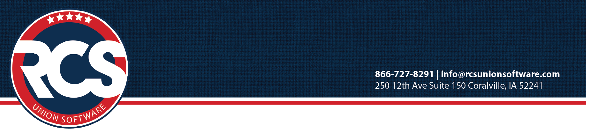

February 2024

Greetings 2024 Conference Attendees,

We look forward to seeing you at the March UAW Financial Officers’ Conference Houston!
Our main goal of the conference is to assist you in successfully and accurately completing your LM and 990.
To meet this goal, we ask you to bring the following information as it relates to your local.

To complete your LM-3 form for 2023 at FOC (BRING THE FOLLOWING) . . .

- 2023 LM Prep Worksheet You must complete this preparation prior to coming to Conference.

If you run in to any issues, please resolve with RCS Support before coming to Conference.

- Calculator
- Copy of the 2022 LM filed with the DOL

Print the following LM report: (By completing the 2023 LM Prep, you have already printed this.)

- LM-3 Worksheet Reports Menu> LM Tab> Select 2023 then generate and print a Worksheet

For LM Statements A and B, bring the following items:

- January 2024 Financial Report Reports Menu> Financial Tab. Run the Financial Report for the date range of January 1-31 2024. (This is used to determine liabilities as of 12-31-2023.)
- Investment statements as of December 31, 2023
- Detailed Asset Listing as of December 31, 2023, for LM statement B
- Detailed List of Assets Purchased and Sold in 2023 & related costs to sell for LM statement B
- Detailed Inventory Listing as of December 31, 2023
- Detailed list of Inventory Sold in 2023 & related costs to sell
- Bank Mortgage Detail January 1 – December 31, 2023 as applicable or any notes payable as of 12/31/23

Expense & Income reports needed: (run reports for all funds.)

- A-43 Cash & Fund Summary Reports Menu> Financial Tab. Run the A-43 for December of 2023
- A-42/A-132 Report Monthly Summary of Cash Received Reports Menu> Income & Expenses Tab
Run the A-132 for the full year of 01/01/2023 – 12/31/2023
- 2023 Financial Report Reports Menu> Financial Tab
Run the Financial Report for the full year of 01/01/2023 – 12/31/2023.
To complete 990N form for 2023 (BRING THE FOLLOWING) . . .

- Your Local’s EIN number and address

We appreciate you completing this prep work prior to conference. This information is necessary to help you complete your LM and 990 and its applicable schedules during the conference. Please call RCS Support at 1-866-727-8291 or email Support@rcsunionsoftware.com with any questions regarding the above requests so they can be resolved before you start.

