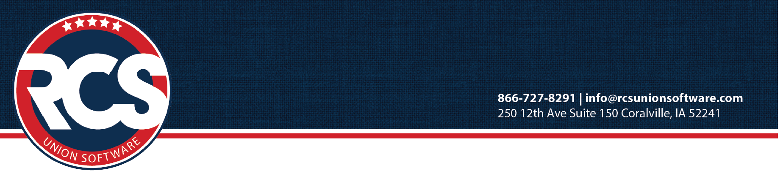

Accessing the DOL’s on-line LM Filing Tool: Electronic Forms System (EFS)

To log into EFS system you will need a User ID, Password, Unions six-digit file number, and a Union PIN.
Be sure to write down and store all of your login information in safe place.

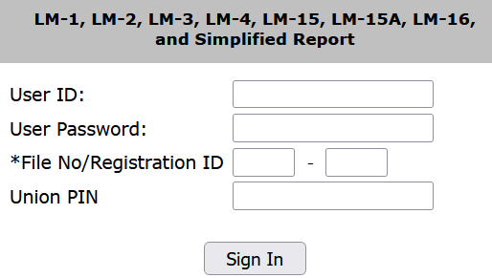
- User Registration – Individuals needing access to prepare, review, or sign the LM Form must register for their own EFS User ID and Password.

- Union Registration – Each union has its own file number and Union Pin. One of the local’s registered users MUST request a new pin annually.

- Open your browser to: www.dol.gov/olms/regs/compliance/efs/efsintro.htm
Note: If you already have an EFS User ID and Password then go to step 5 below.

- Click on the link "Access the OLMS EFS" to reach the page titled “Welcome to the Office of Labor-Management Standards Electronic Forms System (EFS)”.

- Look for "Register for an EFS User ID and Password" -- Click it.
The “User Registration" form should come up. Fill in the form completely, noting:

Are you a filer responsible
for signing the form? Choose Yes if required to sign form; No if review or prepare form only
Phone Number: Include area code; we suggest you use the local's phone number.
Email address: Use an address that is secure; your confirmation will be sent there.
User ID: Maximum of 30 characters (letters, numbers and symbols)
Password: Min 8 characters/Max15 characters. Must include 1 capital letter and 1 number.

When finished click on the “Register Me” button.

- Open your internet browser to: www.dol.gov/olms/regs/compliance/efs/efsintro.htm
- Click on the link "Access the OLMS EFS"
- Look for "Obtain a Union PIN" -- Click it.
Enter your User ID, User Password, and the local's Six Digit File Number. Click Submit.
- Union PIN Registration should display. Verify the information is correct, if not, contact OLMS.
- Enter address to send the Union PIN Registration letter.
- When finished click on the button that says “Register Union”

If everything has been entered correctly you will receive a registration confirmation screen, also an email confirmation will be sent to the email address you provided. A letter will be sent to the address on record for the union notifying officials that PIN has been obtained as a security measure to prevent unauthorized access to the form.
The Union Representative should distribute the PIN only to those who need to access the LM Form.

